# Transforming Functions Worksheet

## Summary of Transformations

|  |  |  |
| --- | --- | --- |
| **Transformation** | **Appearance in Function** | **Transformation of Point** |
| Vertical Translation | f(x)  f(x) + d | (x,y)  (x,y+d) |
| Horizontal Translation | f(x)  f(x – c) | (x,y)  (x+c, y) |
| Vertical Stretch/Compression | f(x)  af(x) | (x,y)  (x, ay) |
| Reflection in x-axis | f(x)  -f(x) | (x,y)  (x,-y) |
| Reflection in y-axis | f(x)  f(-x) | (x,y)  (-x,y) |

**Order of Transformations**

1. Stretches/Compressions and Reflections
2. Translations
3. Given the graph of f(x), sketch the graph of the following functions, and state the domain and range for each:

a. 2f(x – 5)

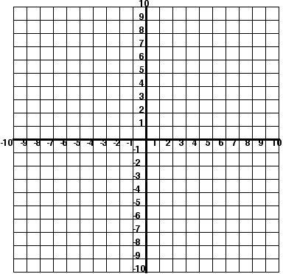

b. –f(x) + 3

|  |  |  |
| --- | --- | --- |
|  | *Functions Review* |  |

Suppose (6,1) is the point of the graph of *y* = *f* (*x*). For each of the following, name a point on the graph then name the transformation.

1. *y*  *f* *x*  2

2. *y*  *f* *x* 5

3. *y*  1 *f* (*x*) 2

4. *y*  *f* (*x*)

5. *y*  *f* *x*  7

6. *y*  4 *f* (*x*)

7. *y*   *f* *x*

8. ____________ _____________________