**Quadratic Functions**

Please complete showing all work algebraically. You can verify graphically but you need to show the algebra work as well for each problem.

1. An object fired vertically upward with an **initial speed v0** is after **t** seconds at a height of , in meters. Given that this object has an initial speed of 68.6 m/s,
   1. What is the maximum height it will reach?

* 1. How long will it take for the object to hit the ground?

1. A farmer wants to build a rectangular fence near a river, and will use 120 ft. of fencing. What are the dimensions of the largest region that can be enclosed if the side next to the river is not fenced?

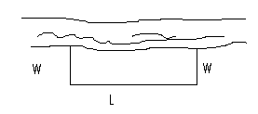

1. Assume that a company knows that the cost to produce x items is given by the cost function  dollars. It also knows that the revenue from x items is given by the revenue function.
   1. Find the Profit function in simplified format.
   2. Find the maximum profit they can expect to make.
   3. How many of these items does the company have to produce and sell to make this maximum profit?
   4. Explain in words what “break even” means.
   5. For this company when will they break even?
   6. Explain in words when the company will make a profit?