***Activity 1.***

PREDICT THE TRANSFORMATIONS OF THE GRAPH OF Y = X2 INDICATED BY EACH OF THE FUNCTIONS BELOW. THEN USE YOUR TI*84 TO CHECK YOUR GUESS.

1. Y = (X + 3)2 - 2 4. Y = (X - 5)2 - 4

2. Y = (X - 3)2 - 1 5. Y = (X + 1)2 + 4

3. Y = (X - 2)2 + 1 6. Y = (X - 3)2 + 2

***Activity 2.***

WRITE A FUNCTION FOR EACH OF THE FOLLOWING GRAPHICAL REPRESENTATIONS.

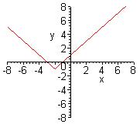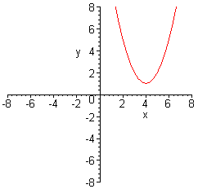A) B) C)

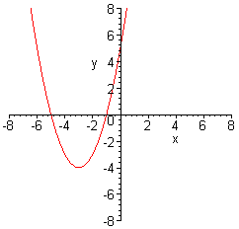

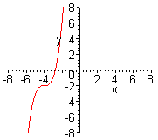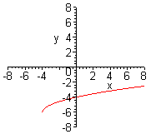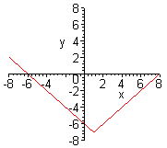D) E) F)

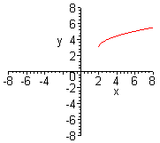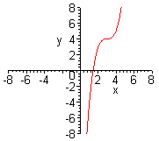

G) H)