MODELING ALGEBRA FINAL REVIEW SHEET

1. (IR) Simplify and write w/ pos. exponents

a) 

b

1. (IR) Evaluate

a)  b) 

1. (IR) Simplify .
2. (I) Which of the following graphs is an appropriate sketch of this scenario*: Jen is standing by a tree, then walks very slowly away from it, turns around and walks quickly toward it, stopping for a drink of water 3 feet from the tree.*

a) *Distance from tree*

*Time*

b) *Distance from tree*

*Time*

c) *Distance from tree*

*Time*

d)  c) *Distance from tree*

*Time*

1. (I) Which of the graphs below is not a graph of a function:

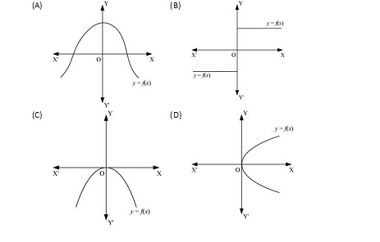

1. (I) Which of the following equations defines *y* as a function of *x* (and which equation is not a function)?

a)  *y* = *x*2

b) *y* = *x*3

c) *x* = *y*2

d) *x* = *y*3

1. (I) Given *f(x*) = 3*x*2 + 2*x*, Find

a) 

b) 

1. (I) Find the domain of

a) 

b) 

c)

d) 

e) 

1. (I) Does the following table display data that is increasing or decreasing. Explain. Assume **Time** is the independent variable.

|  |  |
| --- | --- |
| **Time (hours)** | **Area left to paint** |
| 1 | 350 |
| 2 | 250 |
| 3 | 150 |
| 4 | 50 |

1. (I) Given the accompanying graph, specify the interval(s) over which

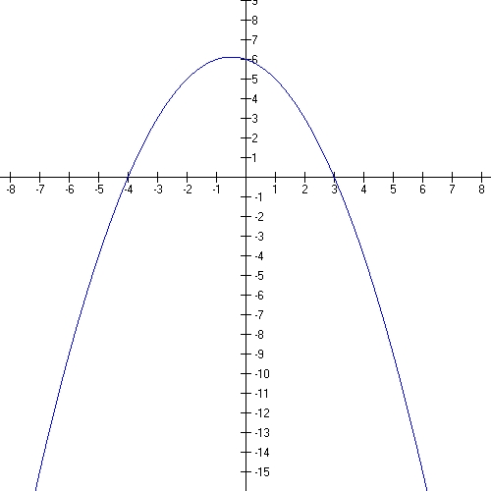

a) The function values are ***positive***;

b) The function values are ***negative;***

c) Find *x* such that 

1. (I) Write a mathematical model that will find the distance, *D*, left to travel after driving *T* hours.

*On the 350 mile return trip from Washington DC, Jen drives at a constant 55 mph rate.*

1. (I) Interpret the slope of the model you wrote above.
2. (I) According to the U.S. Bureau of the Census,

workers’ compensation payments in Florida rose

from $362 million in 1980 to $1.976 billion in 1990.

Find the average rate of change in payments.

1. (I) The table shows the average price of a gallon of milk and the average price of a gallon of gasoline during the first 6 months of 2004.

|  |  |  |  |  |  |  |  |
| --- | --- | --- | --- | --- | --- | --- | --- |
| **Month** | **1** | **2** |  | **3** | **4** | **5** | **6** |
| **Milk** | $1.79 | $2.29 |  | $2.19 | $1.89 | $2.09 | $2.29 |
| **Gas** | $1.93 | $1.96 |  | $1.79 | $1.69 | $1.98 | $1.8 |

Use the definition of function to answer the following questions:

1. Is the average price of gas a function of month? Explain.
2. Is the month a function of the average price of milk? Explain.
3. Is the average price of milk a function of the average price of gas? Explain
4. (I) Population of the city can be modeled by the function P(x)=230,000-8,500x, where x is a number of years in 1990. Answer the following:
5. what does the number 230,000 represent;
6. what does the number 8,500 represent;
7. does the population of the city increase or decrease and at what rate;
8. at what year the population of the city will reach 100,000;
9. what will be the population of the city in 2017;
10. (I) The average mobile-phone monthly bill between and 1998 can be modeled by dollars, where *x* is the number of years after 1995. If the model remains accurate beyond 1998, in what year does the model indicate the monthly bill will be $35.32?
11. (II) Given the pts A(4,-3) and B(2,1), find the slope of the line AB.
12. (II) Write an equation of the line:

a) through  and .

b) with slope of 3 and passes through (-1,5).

c) with zero slope that passes through .

1. (II) Carbon emission of the U.S. in 2017 was 5490.63 million metric tons. A new legislation introduced to the Congress is planning to impose measures to reduce carbon emission by 25,000 thousand tons each year. If the new legislation becomes the law and takes effect in 2017, write a function that predicts the amount of carbon emission in millions of dollars for each year. Let t represent the number of years since 2017.
2. (II) Company’s revenue decreased from 45 million dollars in 2006 to 37 million dollars in 2010. Find a function that represents company’s revenue R(t) as a function of t, where t is the number of years since 2005.
3. (II) A KSU football player ran for 1056 yards in 2000 and for 978 yards in 2004. Find the average rate of change in his performance.
4. (II) In 2005 a record 51.5% of paper consumed in the US was recycled. The American Forest and Paper Association states its goal is to have 65% recovery by 2014, Assuming the growth is linear, find the function, R(t), for the percentage of paper recycled t years since 2000.
5. (II) Name the slope and y-intercept of each of the following lines:

a) 

b) 

1. (II) Joe is hired by an accounting firm at a salary of $60,000 per year. Three years later his salary has increased to $70,500. Assume his salary increases linearly.

a) Find an equation that relates his annual

salary *s* to the number of years *t* that he has

worked for the firm.

b) Interpret the slope and y-intercept in the

context of the problem.

1. (II) If a town starts with an initial population of

100000 and 350 people leave each year, what is

the linear equation that relates the population

(*P*) to the number of years since the town began

1. (II) During a thunderstorm you see lightning before you hear thunder. The distance *d* between you and the storm is given as the *d* = 600*t*, where *d* is in feet and *t* is given in seconds. How far away is the storm if you hear thunder 10 seconds after you see the lightning?
2. (II) If *S(x)* = 45,000 + 500x describes the annual salary in dollars for a person who has worked x years for the Acme Corporation.

a) What is the initial salary?

b) Interpret the meaning of the number 500.

1. (II)Solve each of the following systems of equations:

a)  b) 

1. (II) Consider the following job offers. At ABC Sports you are offered a salary of $25,000 per year with raises of $1500 annually. At XYZ Dance you are offered $30,500 to start and raises of $1,000 annually.
   1. Set up a system of equations that would model the scenario.
   2. After how many years would the two salaries be equal?
2. (II) A certain product has supply and demand functions given by  and , respectively. Find the equilibrium point. If the price *p* is $60, find the number of items supplied and demanded. When the price is $60, does this represent a shortage or surplus? Explain.
3. (II) A retail chain will buy 900 cordless phones if the price is $10 each and 400 if the price is $60. A wholesaler will supply 700 phones at $30 each and 1400 at $50 each. Assuming that the supply and demand functions are linear, find the market equilibrium point.
4. (II) a) Construct a piecewise tax function where the tax is 5 % on the first $15,000 of income, then 12 % on any income over $15,000.

b) Determine the tax payable on an income of $48,000.

1. (II) Given the piecewise function:



Find

a) 

b) 

c)

d)

e)

1. (II) Write a piecewise rule for the function represented by the following graph



1. (II) Find an interval of x values that satisfies the following inequalities (white your answers both in interval and inequality notations):
2. .
3. (III) How are the graphs of each of the following related to the graph of  (Describe function transformations)?

a) 

b) 

c) 

1. (III) Write an equation for a function that has the shape of

a)  but shifted right 2 units and down 3 units.

b)  but stretched vertically by a factor of 2 reflected through the *x-* axis and shifted up 5.

1. (III) Graph each of these.

a)  c) 

b) 

1. (III) How is the graph of  related to the graph of ?
2. (III) How is the graph of  related to the graph of  ?
3. (III) Write the equation of the following function, which is a transformation of 

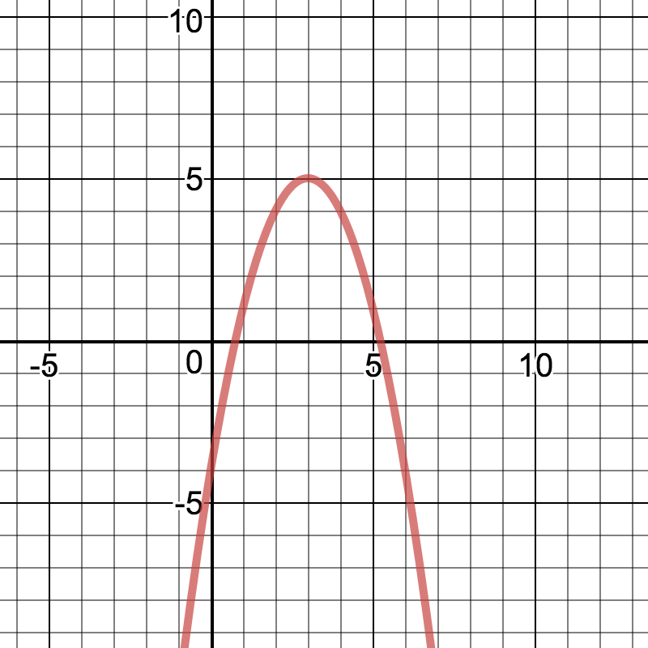

1. (III) If revenue of the company is and cost is , what is the profit function (simplify your equation).
2. (III) A ball is thrown directly upward from a height of 30 feet with an initial velocity of 60 ft/sec. If the height of the ball *t* seconds after it has been thrown is given by the function

, determine the time at which the ball reaches its maximum height and find the maximum height.

1. (III) The profit *p* (in dollars) generated by selling *x* units of a certain commodity is given by

*.* What is the maximum profit, and how many units must be sold to generate it?

1. (III) If a farmer has 1000 feet of fence, a formula for area in terms of the width of the rectangle is . Find the width that will give the maximum area. Then find the maximum possible area.
2. (III) A farmer has 360 yards of fencing with which to enclose two adjacent rectangular plots, one for corn and the other for soybeans. Suppose the width of each plot is *x*.

x

1. Express the total area of the two plots as a

function of *x*.

1. find the maximum possible area.
2. (III) Find vertex of the function . Is the vertex max or min of the function?
3. (III) A ball is thrown straight upward at an initial speed of 40 ft/sec. *Use the formula *

a) When does it reach a height of 24 feet?

b) When does it hit the ground?

1. (III) Solve for *x*:

a) 

b) 

c) 

d) 

e) 

1. (III) Let . Find:
2. all x-intercepts of the graph;
3. all zeros of the function f(x);
4. all solutions to the equation f(x)=0.
5. (III) The formula h (t) = -16 t2 + 32 t + 80 gives the height h above ground, in feet, of an object thrown, at t=0, straight upward from the top of an 80 feet building. Evaluate and describe the meaning of h(3).
6. (IV) The graph below represents a polynomial function. Is the degree of the leading term even or odd? Is the leading coefficient positive or negative?



1. (IV) Consider the following functions:

*a) f(x) = 5x3 +3x-6*

*b) f(x) = -5x6 +7x5*

Name the end behavior for the graph of each of the above.

1. (IV) Suppose the revenue for selling *x* items is given by .

a) Find the number of items sold to give 0 revenue.

b) Find the number of items sold to give revenue greater than 0? Write your answer as an interval.

1. (IV) For the polynomial 

a) Name the zeros

b) Without graphing indicate whether the graph

crosses or touches at each zero.

c) Describe the end behavior of the graph.

1. (IV) Based on the graph below, white the equation of the polynomial function in factored form.

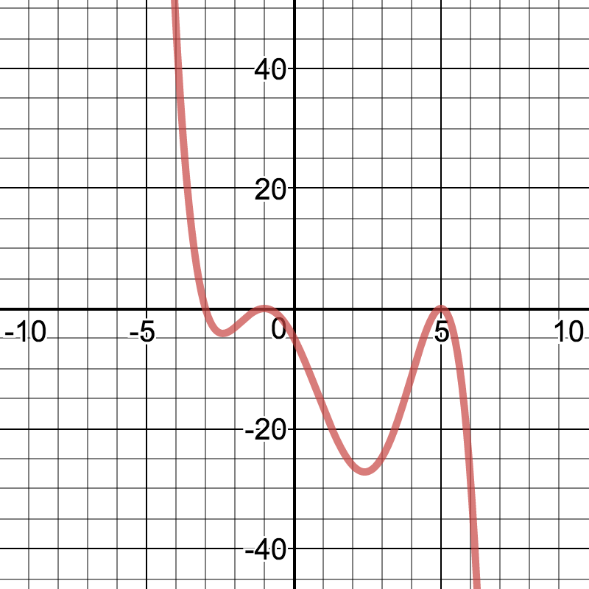

1. (IV) Form a 4th degree polynomial with the following zeros: -5, 3 (multiplicity 2), 0.
2. (IV) Use synthetic division to divide

by and write the quotient and remainder.

1. (IV) List all the possible rational zeroes of each of the following.

a) 

b) 

1. (IV) Find the real zeroes of .
2. (IV) Factor each of the following.

a)

b) 

1. (IV) Solve each of the following inequalities:

a) 

b) 

1. ;
2. .
3. (IV)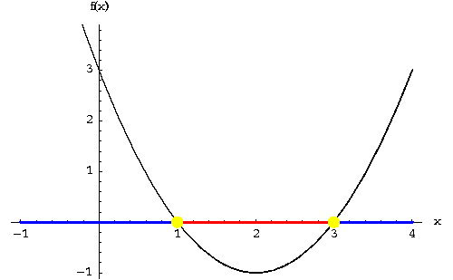

Based on the graph above, find the following:

1. x such that f(x)=0;
2. values of x where f(x)>0;
3. values of x where f(x)<0.
4. (IV) Based on the graph below, find the following:
5. x such that f(x)=0;
6. values of x where f(x)>0;
7. values of x where f(x)<0.

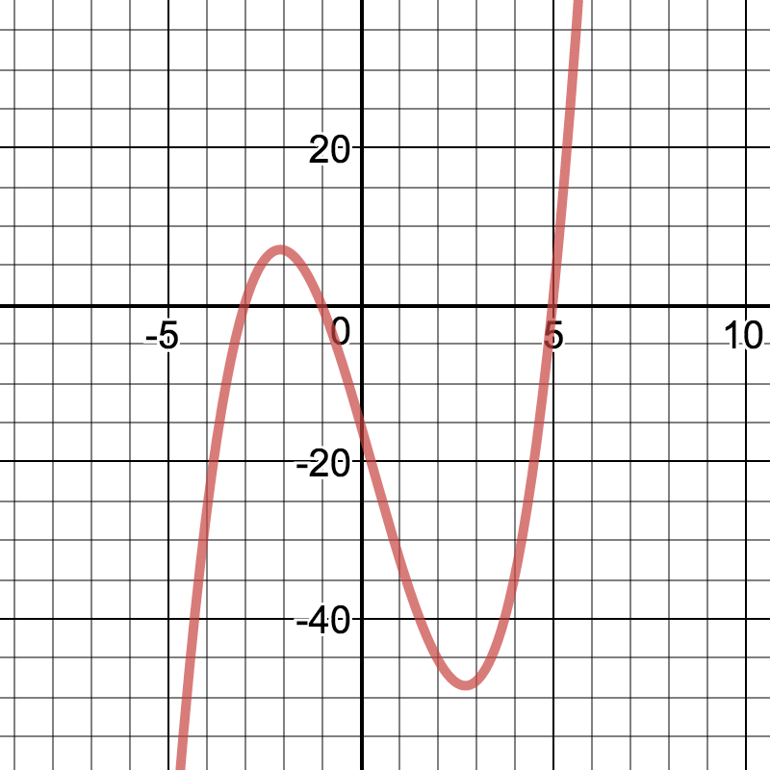

|  |  |  |  |
| --- | --- | --- | --- |
| ***x*** | ***Y1*** | ***Y2*** | ***Y3*** |
| 0 | -2 | 1 | 0 |
| 1 | 1 | 0.3 | 1 |
| 2 | 4 | 0.09 | 8 |
| 3 | 7 | 0.027 | 27 |
| 4 | 10 | 0.0081 | 64 |
| 5 | 13 | 0.00243 | 125 |

1. (I, II, III, IV,V) Given the table below, determine the type of function that would best model the data in each column and write a function representing it (note: you have 3 different functions Y1, Y2, and Y3; reuse the same x column for each of 3 functions).
2. (V) Determine if the model exhibits growth or decay. Identify the initial value, the growth or decay factor, and the growth or decay rate.

a) N = 3815 (1.25)t

b) 

c) 

1. (V) Determine the growth or decay factor, given that the growth/decay rate is:

a) Increase of 25%

b) Doubles

c) Decreases by 17%

1. (V) Graph each of the following, then name the domain, range, initial value, factor of growth or decay, and rate of change.

a) 

b) 

1. (V) Name three characteristics of the graph of an exponential function, where *b* >1 and where
2. (V) The pollution level in a lake can be

represented by an exponential equation

involving the pollution (*P*) and the time (*t*) in

years. At *t* = 0*, P* = 12238, and the pollution

decreases by 32% a year. Write a model to

describe the amount of pollution after *t* years.

1. (V) If a store reduces the price by 15% every week, write a function that would represent the sale price after x weeks.
2. (V) Describe the following properties of the function : a) domain; b) range; c) x-intercept; d) y-intercept; e) horizontal asymptote; f) increasing or decreasing function; g) type of transformation from the parental function.
3. (V) A bunch of hooligans dump 164 pounds of pizza boxes into a lake. If the pizza boxes dissipates at a rate of 31% a year, how many pounds of pizza boxes will be left after 10 yrs?
4. (V) Which job pays more after 7 years: one that pays $46000 initially with a 9.6 % raise every year or one that pays $36000 with a 12.5% yearly raise?
5. (V) If you invest $8,950 in an account paying 6.75% compounded continuously, how much money will be in the account at the end of 15.75 years?
6. (V) Repeat the above problem for each of the following compounding’s:

a) annually

b) monthly

c) daily

1. (V) How long would it take an investment to triple in value if interest is compounded quarterly at 8%?
2. (V) Write in logarithmic form:

a) 0.001 = 10-3 b) c)

1. Write in exponential form:

a) log c = d; b) ln p = q;

c) d)

1. Evaluate: a) log2 32; b) log1/4 16; c) log1/3 81
2. Expand using properties

a)  b)  c) 

1. (V) Write as a single logarithm: 
2. 82. (V) Solve for x.

a)  c) 

b)  d) 

e) 

f) 

g) 

1. (V) The magnitude of the earthquake can be calculate by the following formula:  , where I is the earthquake intensity, and I0 is the reference intensity of the earthquake with zero magnitude. What is the magnitude of the earthquake with intensity that is 55,432 times higher than I0.
2. (V) Acidity of a solution or mixture (so called pH level) can be calculated using the following formula pH=-log (H+), where H+ is the amount of hydrogen ions in the solution. What is the amount of hydrogen ions in the solution that has pH level equal to 5.6?
3. (V) Given and

a) Find ; b) Find

1. (V) Supposed you went to a store and were offered a 30% discount, D, from the original price, x, of every product you buy at the store today. In addition, you are offered a $20 coupon, K, that you can use in a combination of the offered discount. Explain what each composition function mean and indicate the order you apply your discount and a coupon:

a)  ;

b)  ;

1. (V) Graph the following functions. Based on the graphs, which of the following functions are one-to-one, i.e. have an inverse?

a)  b)

c) 

d) 

1. (V) Which of the following graph represent a one-on-one function:

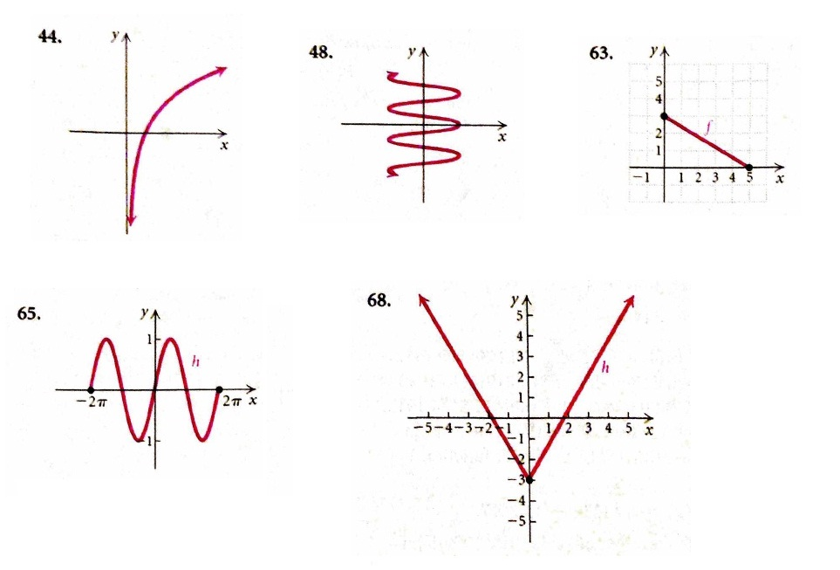

1. (V) Sketch the inverse of the function represented by each graph below.

a)



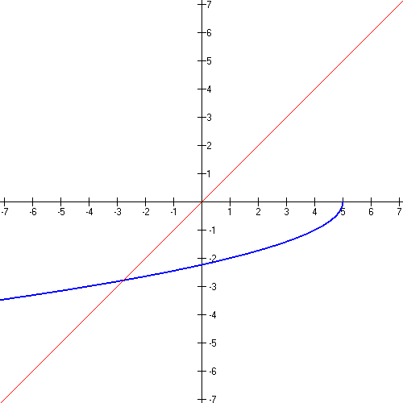

1. (V) Find the inverse of each of these

a) *f(x)* = 

b) *g(x)* = 

c) *h(x)* = 

1. (V) Suppose Eddie’s Pizza charges $9 for a large pizza plus $1.50 for each topping. Thus the function to determine the cost, *C,* of a large pizza with *x* toppings is . Find the inverse of this function. What do the outputs of the inverse represent?
2. (V) A number of pizzas, P, made in the local pizzeria per day depends on the number of employees, w, working that day and given by the formula . Explain what the inputs and outputs of inverse function represent.