**Set up each system of equations clearly defining the variables of interest then solve using the elimination or the substitution method. You must show all work clearly**

1. John bought 2 computers, one desktop and one laptop. Before finance charges, the laptop cost $500 more than the desktop. John paid for the computers using two different credit cards. For the desktop, the interest rate was 5% per year and the laptop it was 7.5% per year. The total finance charge for one year $587.50. How much did the desktop and laptop cost before the finance charges? C:\Documents and Settings\emulquee\Local Settings\Temporary Internet Files\Content.IE5\WJBQC3IJ\MC900286606[1].wmf
2. Best Rental charges a daily fee plus a mileage fee for renting its cars. Bill was charged $132 for 3 days and 300 miles. His friend Myles was charged $235 for 5 days and 600 miles. What does Best Rental charge per day and per mile?
3. A petroleum company has two different sources of crude oil. The first source provides crude oil that is 20% hydrocarbons, and the second one provides oil that is 70% hydrocarbons. In order to obtain 180 gallons of crude oil that is 30% hydrocarbons, how many gallons of crude oil must be used from the two sources?
4. 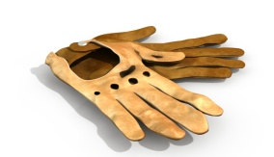One day a business sold 20 pairs of gloves. The cloth gloves sold for $4.95 per pair and the leather gloves sold for $7.50 a pair. The business took in $137.25. How many of each kind were sold?
5. 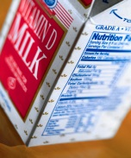An individual wants to use milk and orange juice to increase the amount of calcium and vitamC:\Users\emulquee\AppData\Local\Microsoft\Windows\Temporary Internet Files\Content.IE5\BOMJLGE4\MC900090177[1].wmfin A in her daily diet. An ounce of orange juice contains 5 milligrams of calcium and 60 micrograms of vitamin A. An ounce of milk contains 38 milligrams of calcium and 56 micrograms of vitamin A. How many ounces of milk and orange juice should she drink each day to provide exactly 550 milligrams of calcium and 1,200 micrograms of vitamin A?
6. A supplier for the electronic industry manufactures keyboards and screens for graphing calculators at plants in Mexico and Taiwan. The hourly production rates at each plant are given in the table below. How many hours should each plant be operated to fill an order for exactly 4,000 keyboards and 4,000 screens?

|  |  |  |
| --- | --- | --- |
| Plant | Keyboards | Screens |
| Mexico | 40 | 32 |
| Taiwan | 20 | 32 |

1. A jeweler has two bars of gold alloy in stock, one 12 carets and the other 18 carets (24 carat gold is pure gold, 12 carat gold is pure, 18-carat gold is pure and so on). How many grams of each alloy must be mixed to obtain 10 grams of 14-carat gold? 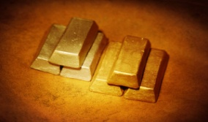
2. In the United States, the number of nuclear power plants in the South exceeds that in the Midwest by 11. Together these two areas have a total of 73 nuclear power plants. How many are located in the South?