**Revenue, cost, and profit (p. 83 in textbook)**

***Revenue***: where p = selling price per unit

***Cost***: where k = fixed cost (FC), c = variable cost per unit (VC) or rate of change

***Profit***:

*Marginal revenue, cost, or profit = Slope of the function*

Suppose a company manufactures Blu-ray players and sells them to retailers for $98 each. It has fixed costs of $262,500 related to the production of the Blu-ray players, and the cost per unit for production is $23.

1. What is the total revenue function? (if you write only you have NOT written a revenue function, a function must have an equal sign)
2. What is marginal revenue for this product?
3. What is total cost function?
4. What is the marginal cost for this product? Is the marginal cost equal to variable cost or the fixed cost? Explain.
5. What is the profit function for this product?
6. What is the marginal profit?
7. What are the revenue, cost, and profit if 0 units are produced?

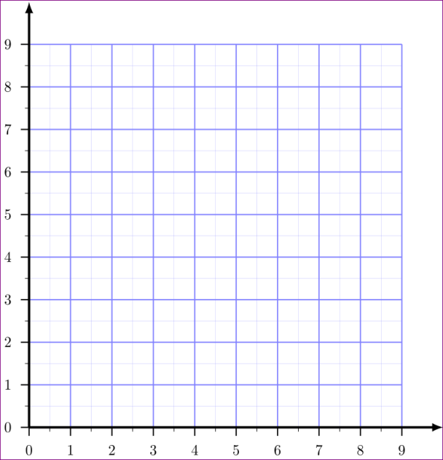 

1. Graph the total cost and total revenue functions on the same axes and estimate where the graphs intersect. (Label the units on both of your axes, think alignment and scaling!)
2. Graph the profit function on the second grid above and estimate where the graph intersects the x-axis (x – intercept). Use the same “scaling on this graph as you did for problem 8. You will have to extend the vertical axis.
3. Compare the intersection point from #8 and the x - intercept Question 9?

What do you notice about these points?